Project Design Phase-I

Proposed Solution

|  |  |
| --- | --- |
| TEAM ID | 46561_46561_1660750242 |
| PROJECT NAME | IoT Based Safety Gadget for Child Safety Monitoring &Notification |

Proposed Solution

|  |  |  |
| --- | --- | --- |
| S.No | Parameter | Description |
| 1. | Problem Statement (Problem to be solved) | Tracking the child activities, location and notifying their position to their parents. |
| 2. | Idea / Solution description | Designing the project with sensors like temperature sensor, heartbeat sensor, using long range camera with high storage and protecting by emitting harmful light sources or gas. |
| 3. | Novelty / Uniqueness | In this proposed system, gas emitter or harmful light source or smoke detector is used than other systems. |
| 4. | Social Impact / Customer Satisfaction | Secured information, cost efficient and Real-time tracking is possible. |
| 5. | Business Model (Revenue Model) | The proposed system can be used for child security.  Selling the product directly to the parents  Selling the product to the child care centers |
| 6. | Scalability of the Solution | The proposed system has less complexity and portable system. Highly secured database handled and highly strong communication. |

Project Design Phase-I

Problem Solution

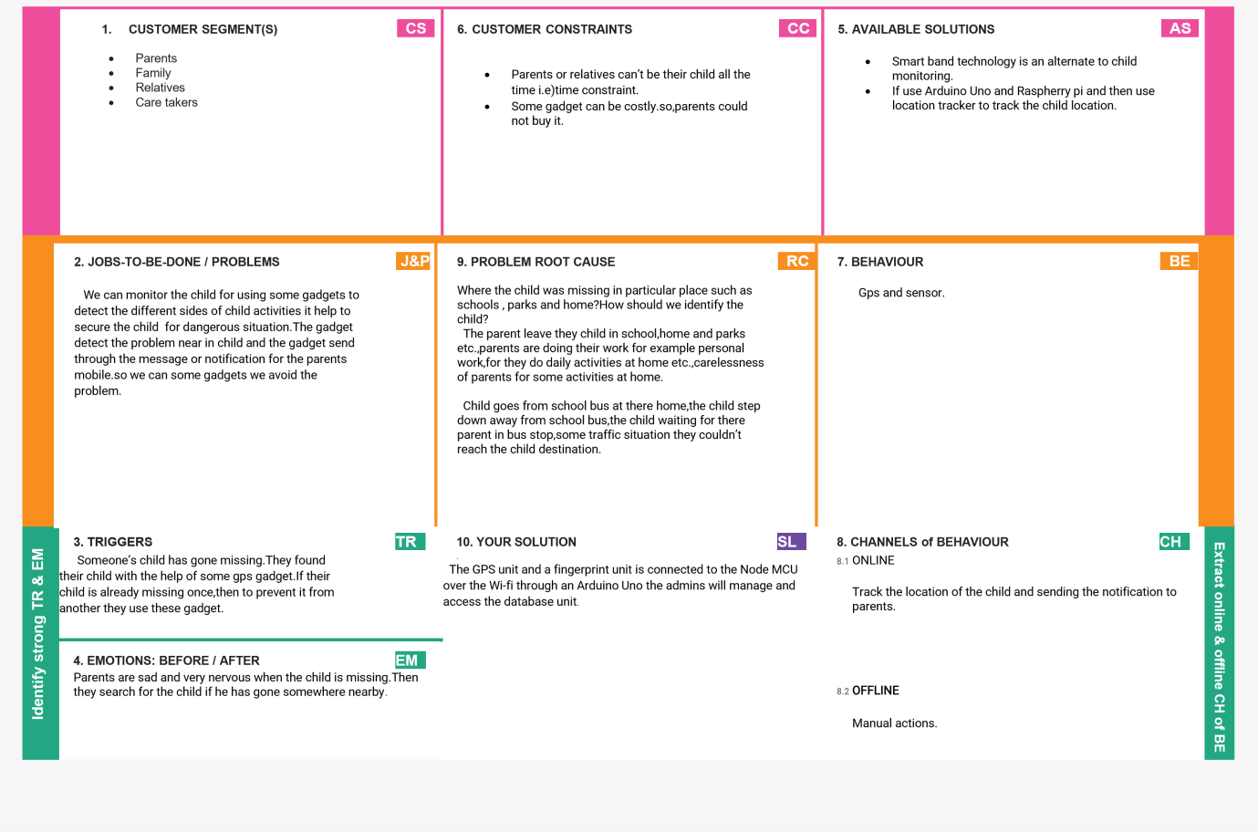

Project Design Phase-I

Solution Architecture

